# Project: Product Shop

Product Shop is a system that registers users, categories, products and orders. It is a significantly big project, and as such it will have several parts. In this exercise you will land the basics of the application, in other words - the user functionality.

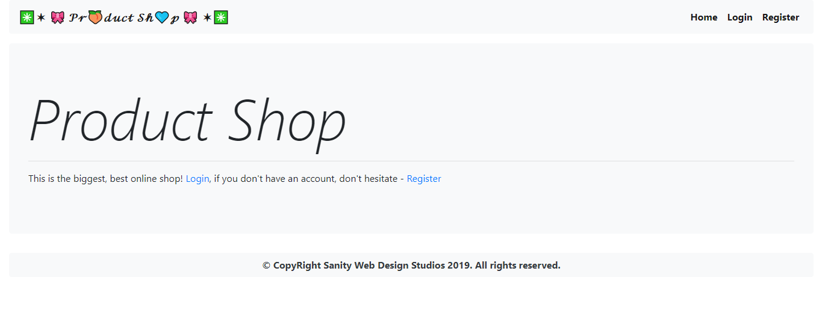

# Workshop: Part 1 - Users

## Views

You will be given a couple of views.



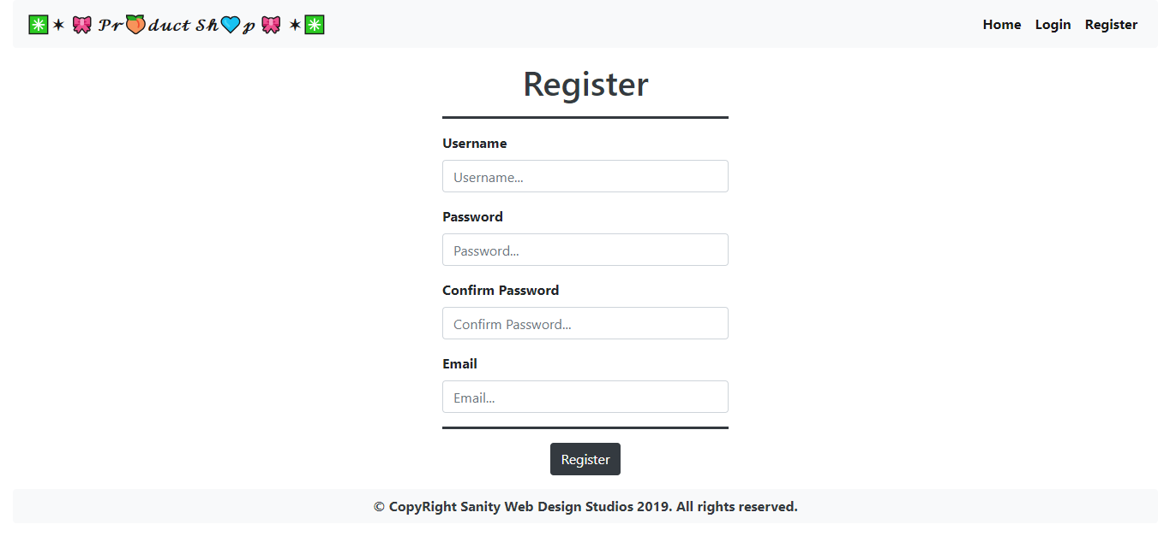

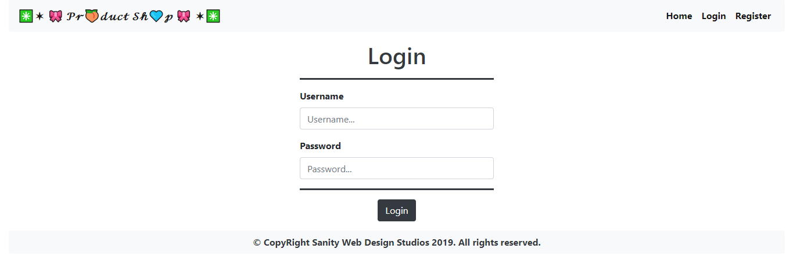

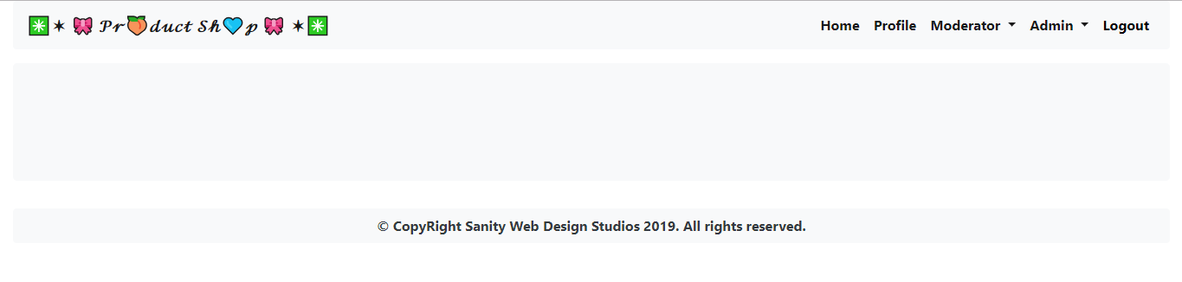

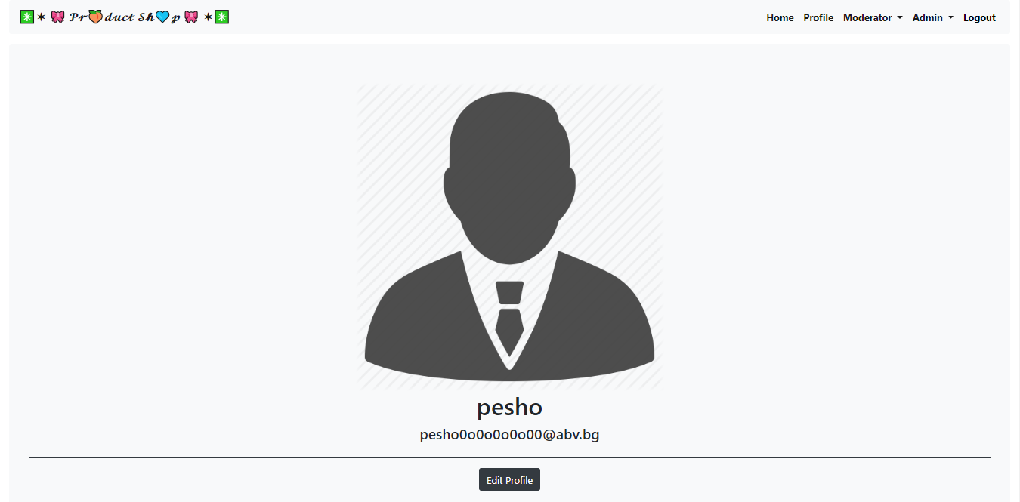

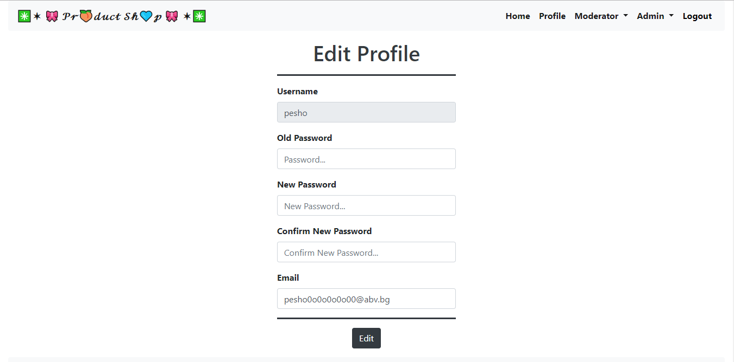

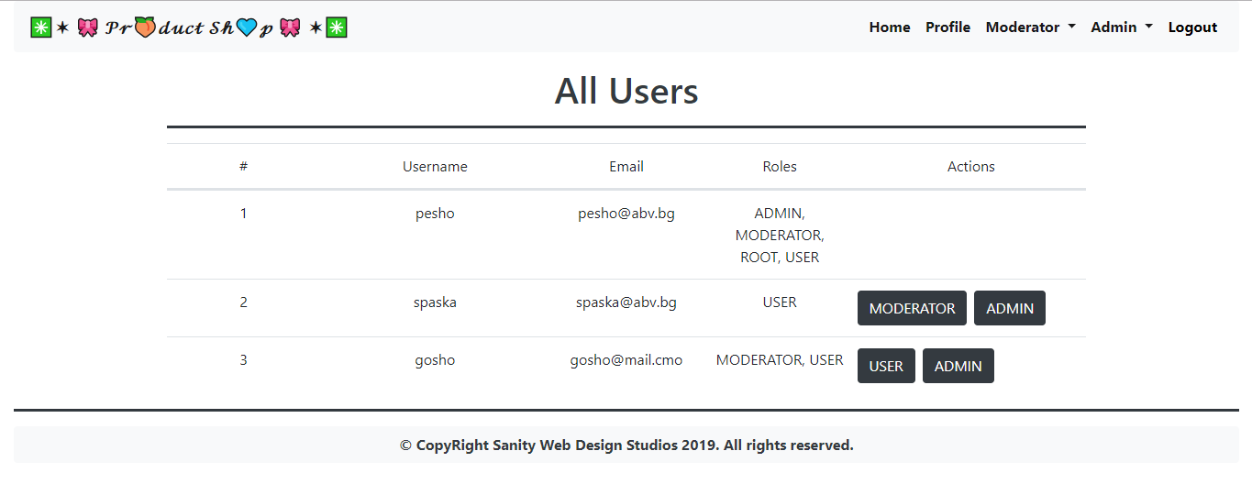

## Data Entities

Create the required **entities**. Use the appropriate **data types**. In this exercise you will have Users and their Roles

* **User**
  + **Id –** primary key, universally unique identifier
  + **Password –** string
  + **Email –** string
* **Role**
  + **Id –** primary key, universally unique identifier
  + **Authority -** string

## Establish the Back-End

Create the required:

* **Entities**
* **Models**
* **Repositories**
* **Services**
* **Controllers**

## Register User

Create a functionality to **register** Users.



## Login User

Create a functionality that **logs in** user.



## View Profile

Create a functionality to **view** the current logged in user’s profile. You should be able to go to edit profile page.



## Edit User’s Profile

Create a functionality to **edit** User, in other words a functionality that can change the user’s password and/or email



## Admin Functionality

Admins should be able to see all users and change their roles

